Suggested Tackle List:
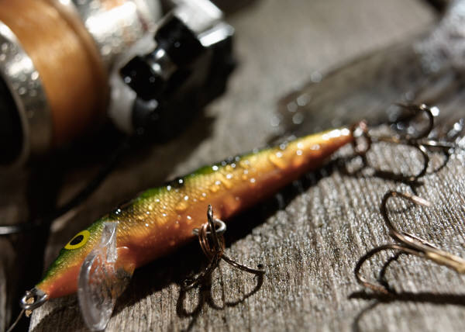

TOPWATER (minnow imitating baits)

Rapala Floaters Floating and small lipped Frogs
Rebel Floaters Buzz Baits
Smithwick Rattlein Rogue

TOPWATER (prop baits)

Heddon Torpedoes (tiny and baby) Cotton Cordel
Crazy Shad Zara Spooks- (no propeller)
Smithwick Devils Horse

MEDIUM RUNNING LURES

Rapala Shad Raps size 5,7,8,9 Smithwick Suspending Lures
Bomber Model “A” 2 ½, 3 ½, Weedless Spoons
Rebel Crawfish Hot-N-Tots
Mepps Spinners Mann’s Deep Divers

DEEP RUNNING LURES
Rattlin Rapala
Bill Lewis Rat-L-Trap
BRING ALSO: 1/4 oz. And 3/8 oz. Lead head jigs – chartruse in color
SUGGESTED LINE: 8 # test most common on a medium to lightweight spinning rod
STRINGER
STEEL LEADERS

